Pre-Reading

The Zoo
The first word that we are going to learn today is 时候 (shi2hou), this means “when,” but this words location in a sentence is a little strange. For example if I say 我小的时候 (wo3xiao3de shi2hou) this means “When I was little” but notice how 时候 comes at the end of the sentence. Also in this word you should note the first character， 时， means time, you will see it in other words such as 时间 which means “time.” The second word is an easy one 朋友 (peng2you2), both of these characters mean friend or friendship, so together they also mean friend. I usually remember the first character by imagining two 月（yue4）, or moons, together and these two 月 represent two friends together. 朋友 often has a either a 男 (nan2) or a 女(nv3) in front to express boyfriend and girlfriend respectively. 男 is easy to recognize as man, because the top of the character 田 （tian2）means field and the bottom character 力(li4) means strength, so you can imagine a long time ago it was thought that you needed a strong man to work the fields. The writer’s sister and her boyfriend go to the 动物园 (dong4wu4yuan2) or the zoo and will see a lot of animals, but first let’s look at 动物园. First 动 means to move you’ll see it in words like 运动 (yun4dong4) which means sports. The second words is 物 means “object or thing” so an animal is a moving object (interesting view of animals right??), the last word 园 you saw in 公园，which means enclosed area. Before we study the animals there are two more words we need to look at first is 经常 (jing1chang2) which means often, 我经常睡觉, I often sleep. The second word is 走一走 (zou3yi1zuo3), the word 走means “to leave or to go for a walk” In Chinese often times the verb is doubled and an 一 is placed in between, when this happens it means that the action being done is relaxed and done without necessarily trying to reach a goal. For example 我们听一听, let’s just listen for a while, or 你看一看 let’s go take a look, 我们去玩一玩, which means let’s play for a bit. The first animal is 熊 (xiong2) which is bear, the next one is 鸟 (niao3), which is supposed to be a pictograph of a bird. After that we have a猴子 (hou2zi3) which is monkey, but the first character in this word has two interesting parts. First, if you notice the left side of the 猴character you’ll see the animal radical. It appears in characters like 狗(gou3) and 猫 (mao1) which are dog and cat respectively. The other easy way to remember 猴 is the right side of the word is the same as in the second character of 时候. The last animal they talk about is a 熊猫 (xiong2mao1) which means Panda, you should recognize the first character as bear and the second character as cat, so a panda is a bear cat…don’t ask me how that came to be. The next word we see is 觉得 (jue2de), you should recognize 得 from 记得which is to remember. Here 觉 means to feel or sense, when combined with 得 it means “to think,” but in the terms of expressing your opinion, for example 我觉得他很好, this means I think he is great. Next we have three adjectives to discuss, the first is 可爱 (ke3ai4) which simply means cute, 少 (shao3) which is not to be confused with 小 (xiao3), 少 means “few or rarely” where as 小 means “small.” The last adjective is 可怜 (ke3lian2) which simply means sad and pitiful.
Story Character Count = 85

Vocabulary/Writing

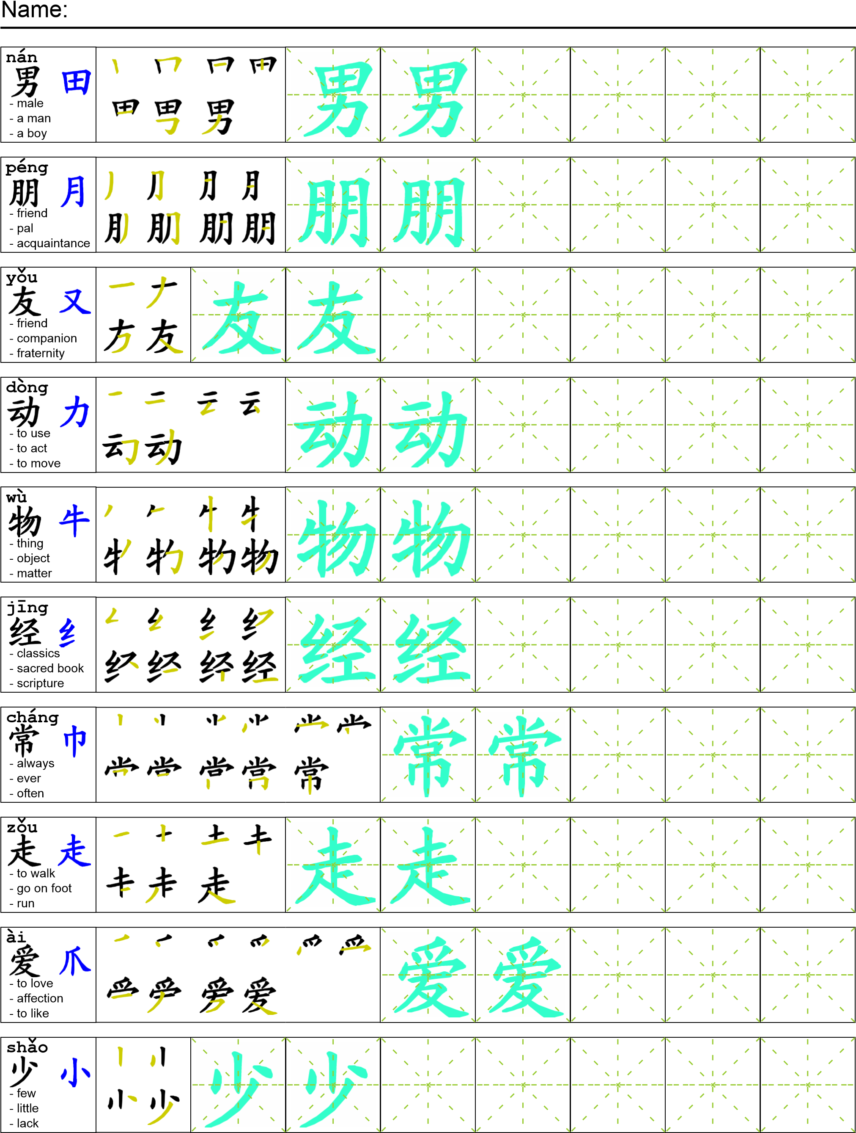
Reading

我在公园的时候我的妹妹和她的男朋友去了动物园。他们经常去动物园走一走。他们喜欢看熊，鸟，和猴子。不过他们最喜欢的动物是熊猫。他们觉得熊猫很可爱。 我很少去动物园因为我觉得那些动物太可怜。

Task Completion

Once all tasks are complete turn the assignment in to collect the points for the project.
Task 1: Trace the vocabulary and copy the text into you notebook.

Task 2: Answer Comprehension Questions.

Task 3: Write the Pinyin for the Reading.

Task 4: Translate the Reading into English.

Task 5: Record yourself reading the passage.

Comprehension Questions
- Write four animals that you learned in this reading. _______________________________________
- 你觉得什么动物可爱？_____________________________________________________________
- How do you say “when” in Chinese? ___________________________________________________
- 你不喜欢什么动物？_______________________________________________________________

